COMHAIRLE CONTAE FHINE GALL
FINGAL COUNTY COUNCIL

Planning and Strategic Infrastructure
Strategic Policy Committee

Monday 23rd July 2018

ITEM No. 3 Fingal Greenways

The following greenway schemes are currently being progressed by Fingal County Council:

- Royal Canal Greenway.
Engineering design, environmental assessment and route option development is currently underway for the Royal Canal Greenway, a proposed walking and cycling route that will run for some 8km between the 12th lock, Castleknock and the Fingal/Kildare county boundary. The proposed scheme will form part of the national Dublin-Galway greenway to the west and will link into existing and proposed greenway schemes in Dublin City and Kildare. A number of surveys are currently underway over the summer along the proposed route.

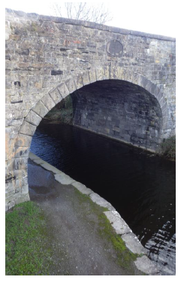

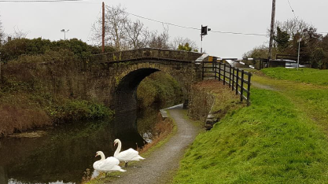

- Baldoyle - Portmarnock Greenway
The Baldoyle and Portmarnock Pedestrian and Cyclist scheme was submitted to An Bord Pleanala on the 7th of February. The deadline of submissions to ABP was the 23rd March. Decisions by the Bord can take a number of months. The Council intends to issue tender documentation for the works if and when planning approval is granted.

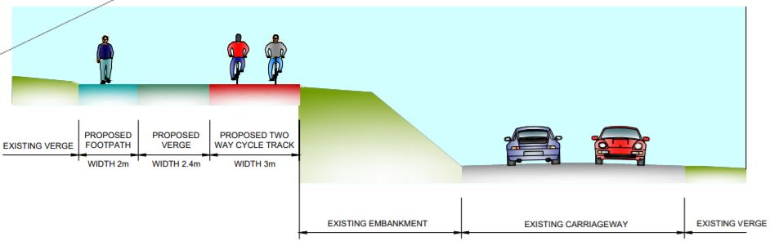

- Sutton - Malahide Greenway
Non-statutory public consultation took place for a number of routes late in 2017. Following the submissions received, a preferred route corridor is being progressed to preliminary design at present. Local consultation is planned for later this year as there are a number of private properties and car parking areas likely to be affected.

- Broadmeadow Way
The final documents are being prepared for this project with a submission date to An Bord Pleanala in the next two months. A decision on planning is likely to take a minimum of six months, following which there will be further clarity on the future steps for implementing this scheme.

- Donabate to Meath Border Greenway.
The initial procurement of an engineering consultant to prepare the planning and design is currently underway. This scheme will form part of the Fingal Coastal Way. Depending on the emerging route options, the scheme may proceed as either one large project or a number of smaller phases, e.g. Donabate-Skerries, Skerries-Balbriggan, etc.

- Kinsealy Greenways Feasibility Study
A draft report has been prepared for this study and is currently with the consultant for finalisation following comments from FCC. It is planned to finalise the report over the coming weeks.

- Lusk-Rush Feasibility Study
A procurement has recently taken place to appoint an engineering consultant to undertake a feasibility study in relation to the provision of cycle linkages between Rush and Lusk.

